Lesson 5
Topic of the lesson: Where I live
Grammar: There is/There are
Positive
There’s a sofa in the living room
(There’s = There is)
Negative
There isn’t a TV
There aren’t any photos.
Question
Is there a TV in the kitchen?
Are there any magazines on the table?
How many CD’s are there?

Please speak about where do you live in a flat or in a house.

1.Look at the picture. Listen and repeat the rooms of the house.
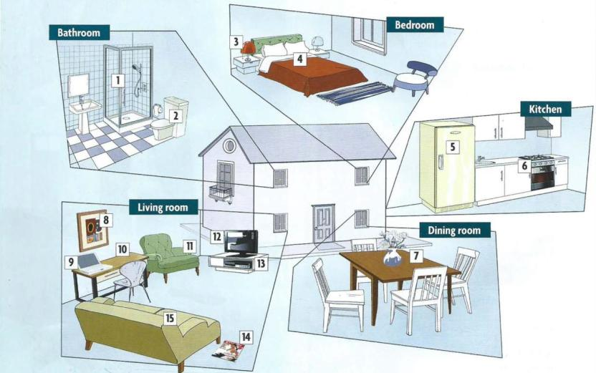

- Find the tings in the house. Write the numbers.

4 a bed a TV a table a lamp a DVD player
a cooker a shower a fridge a picture a laptop
a sofa a toilet an armchair a magazine a desk

- Read and listen to Robert describing his living room. Complete his description.

My living room isn’t very big, but I think it’s great. There is an old sofa, and there are two armchairs. …………….’s a table with a TV and a DVD player on it.
…………… …………. Also a PlayStation. I love all the games. There …………. Some books, and …………… are a lot of pictures and posters on the walls. …………… …………. two lamps. My room’s not very tidy but it’s really comfortable.

- Talk about Robert’s living room.
Eg: There is an old sofa. There are two armchairs.
a sofa a table posters
armchairs books a PlayStation
a DVD player lamps

- Ask and answer questions about Robert’s living room.

a TV Is there a TV? Yes, there is.
Photographs Are the any photographs? No, there aren’t.
a desk
a telephone
lamps
a DVD player
a PlayStation
magazines

- Read the conversation and then practice with your partner.
Robert and his mum
R=Robert M= mum

R Hi mum
M Robert. How are you? How is the new flat?
R It’s great, Mum. I love it. It’s really comfortable.
M and tidy?
R Er- well…..
M So, tell me about it. Is there a nice sofa?
R Well, there is an old sofa but it’s OK.
M Are there any chairs?
R Yes, of course, there are chairs. There are two big armchairs.
M Good. And a TV? Is there a TV?
R. Oh, yes, there is. The Tv’s really big. And I have a DVD player and PlayStation and…..
M A PlayStation? Why?
R I love playing games!
M OK, OK. So is there a desk?
R There is not a desk in a living room but there is one in the bedroom.
M Good. Now, are there any pictures on the walls? Any photographs of your family?
R Well, in the living room there are my posters of New York and Sydney but there aren’t any photographs, they’re all in my bedroom.
M Ok. Now your father and I want to see this flat. Can we visit next……
R Visit? You want to visit?
M Yes. We’re free next weekend. Can we come?
R Er – next weekend – er sorry Mum, I think ……

NEW WORDS
Living room მისაღები ოთახი
Bedroom საძინებელი
Bathroom სააბაზანო
Dining room სასადილო ოთახი
Kitchen სამზარეულო
A cooker გაზქურა
Poster პლაკატი
Tidy სუფთა, მოწესრიგებული

Exercises:
1.Complete the sentences with a room in the house.
- We eat in the dining room
- We relax and watch Tv in the ……..........
- We cook in the …………………………..
- I have a shower in the ……………..........
- I sleep in my …………………………….

2. underline the correct word.

- We keep milk in the …a……
- Fridge b. shower
- I sleep in my ……………….
- Desk b. bed
- We kook lunch on the ………….
a. Cooker b. fridge
4. I sit on the …………. When I watch TV.
a. laptop b. sofa
5. I do my homework at my …………
a. desk b. lamp
6. we sit at the …………. When we gave lunch.
a. desk b. table
7. I play games on my ………..
a. DVD player b. laptop
8. our dog always sits in my father’s ………….
a. armchair b. bag

3. write the number of the picture to the correct word.

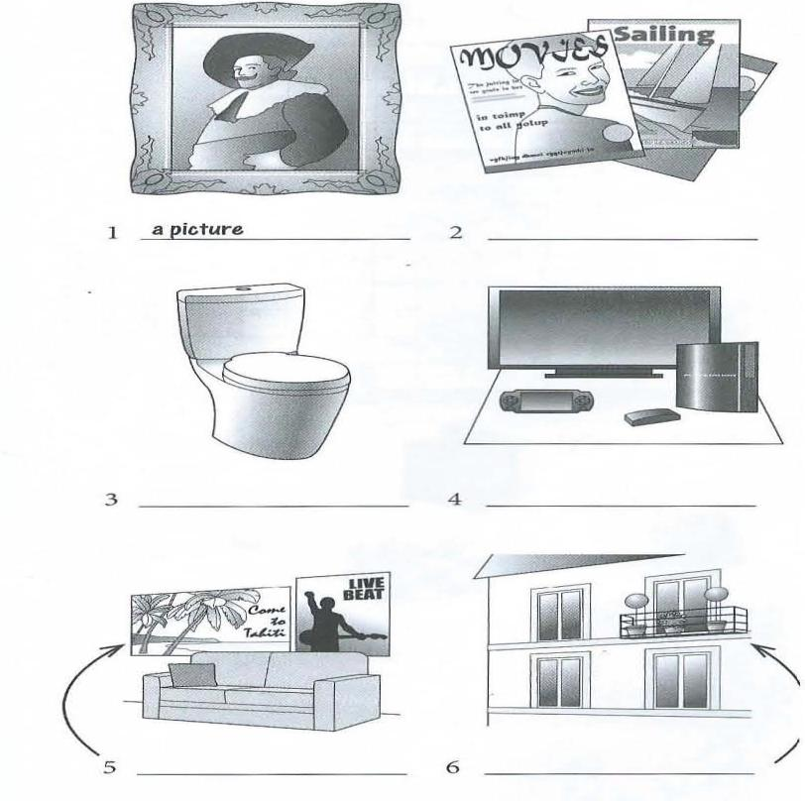
1 - a picture poster a PlayStation
a balcony magazines a toilet

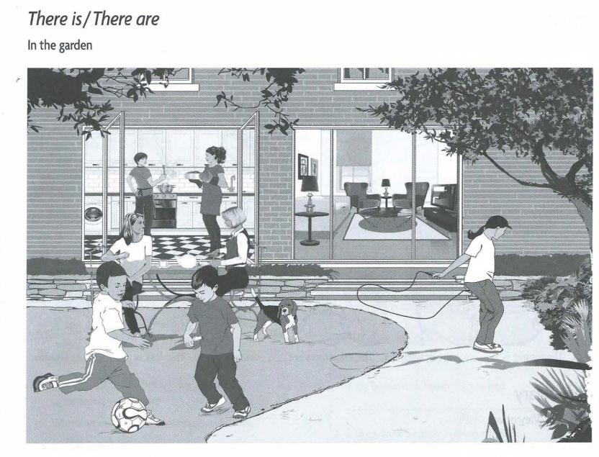

- Look at the picture, are the sentences true or false?
- There are two boys playing football. T
- There is a PlayStation in the living room.
- There is a table in the kitchen.
- There are three lamps in the living room.
- There is a cooker in the kitchen.

5.complete the sentences with There’s or there’re.
- There’s a table in the garden.
- ……………. Two women sitting at the table.
- ……………... a pot of tea on the table.
- ………………a dog in the garden.
- ……………….two people cooking in the kitchen.
- ……………… a sofa in the living room.

6.Make negative sentences with There isn’t or there aren’t
- There aren’t any posters on the wall.
- …………….. a cat in the house.
- ………………any flowers in the garden.
- ………………. A Play station in the living room.
- ……………….. any people in the living room.
- ………………… a DVD player.

- Complete questions and answers.
- Is there a balcony? No, There isn’t.
- ………….. a girl in the garden?...............................................................
- …………....any armchairs in the living room?.......................................
- …………… any children in the house?...................................................

Note: Please write in some words about your room.

